Game Design Document
Yellow Death : Revenge List
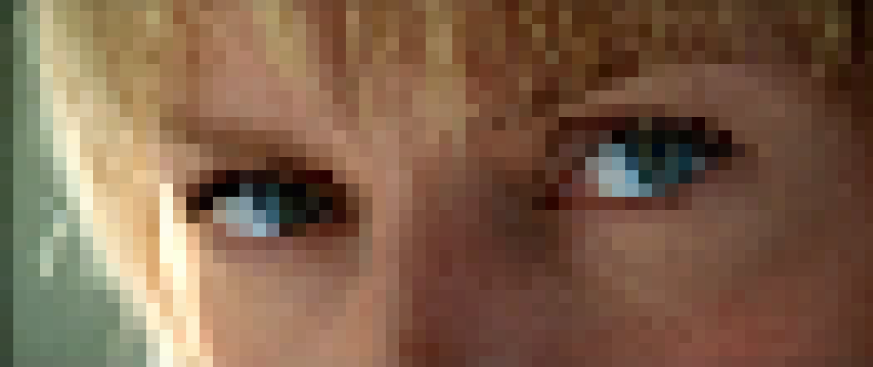

Table Of Contents

Game Overview
- Pitch
Yellow Black : Revenge List, you’re a silent warrior with one goal : cross every name off your Death List. Armed with choices of six distinct katana weapons, fight through iconic locations from suburban homes to final showdown at scluded villa.
Inspired by KILL BILL stylized violence and martial arts cinema, Yellow Black delivers 2-3 hours (probably) of intense, skill based sword combat where every parry, dodge, and strike matters. Master the combat, defeat five bosses, and achieve your revenge.
- High Concept
- Genre : Linear Action
- Perspective : 2D Top-Down View
- Platform : PC
- Playtime : 2 hours (probably)
- Structure : Hand Crafted Level
- Reference
- “Kill Bill” – Revenge driven & stylized violence
- “Ronin: The Last Samurai “ – Lone warrior fantasy, sword combat

  - Feel of Revenge

Design Pillars

The game is entirely focused on revenge. Every level, enemy, and boss exists to move the player closes to crossing the next name off the Death List. There are no side activitites or disctractions
2.2 Feel of Sword Combat
Combat is based on weapon mastery, timing, and precision rather than overpowered stats upgrades. The player succeds by learning enemy patterns and executing clean attacks, dodges, and parries.
2.3 Feel of Watching Kill Bill
The game should feel like watching KILL BILL while playing. Short, stylized cutscenes, dramatic introductions, audios cues, freeze frames, and strong visual emphasis are used to heighten cinematic impact without interrupting gameplay

3.1 Flow

Core Gameplay
Chapter I – Pasadena Suburs
Movement & combat tutorial : Vernitta Green
↓
Chapter II – Okinawa Sushi Bar
Weapon choice & mastery : Hattori Hanzo
↓
Chapter III - House of Blue Leaves
Crazy 88 -- Gogo yubari, Johnny Mo, & O-Ren Ishii
↓
Chapter IV - The Deserts
Immediate Death vs Budd -- Combat Mastery Pai Mei
↓
Chapter V - Deserts Trailers
Elle Driver Combat
↓
Chapter VI - Bill’s Villa
Final boss : Kill Fucking Bill

  - Feel of Revenge

Control Maps

Action Control s
Movement | WASD
Light Attack | Left Mouse Click
Heavy Attack | Right Mouse Click
Dodge | Space
Parry | C
Block | C (Hold)

4.2 Camera Design
- Camera View : 2D Top-Down
- Smoothing : Follow Player with Slight Delay
- Shake : Camera shake intensity based on enemies types

